[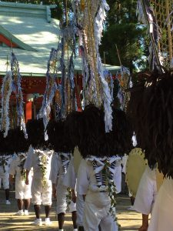](http://wada.jpn.org/wp-content/uploads/2016/08/image-54.jpeg)